Reflective Narrative
Smart Student Planner - React Native Mobile Application
LDC6004M - Mobile Application Development

1. Design Decisions

Choice of Framework
React Native was selected as the development framework for Smart Student Planner due to its cross-platform capability, large ecosystem and good community support. Kivy was recommended as the default option, however React Native had several compelling advantages for this project. Its component-based architecture naturally lends itself to the MVVM pattern, allowing for a clean separation of UI elements and business logic. We chose Expo as the managed workflow, which made the build process much easier and we did not have to set up separate native build environments for Android and iOS. Moreover, React Native’s declarative syntax and hot-reload capabilities expedited the development process, allowing for rapid iterations on UI designs without the need for extensive recompilations. The existence of well-maintained libraries like React Navigation and AsyncStorage also reduced the amount of boilerplate. Also, there are well-maintained libraries such as React Navigation and AsyncStorage that reduce the amount of boilerplate code and allow more time spent on feature implementation and refinement of user experience..
Evaluation Metric | Kivy (Default Recommendation) | React Native (Implemented Workflow)
Development Paradigm | Python-based imperative UI widget layouts. | JavaScript ES6 declarative component-based UI.
Native UI Fidelity | Custom non-native UI rendering via OpenGL (does not match iOS/Android standards). | Direct mapping to native platform primitives (produces high visual fidelity).
Toolchain & Build | Manual build environments (Buildozer) for package bundling. | Expo Go managed workflow (instant hot-reload, managed bundler).
State & Context APIs | Manual property bindings or Kivy state managers. | Native React Context API & Custom Hooks (state encapsulation).

UI/UX and Navigation Decisions
The application adopts an Apple Human Interface Guidelines-inspired light and clean aesthetic, chosen to create a calm, focused environment appropriate for academic task management. The colour palette centres on a soft blue primary accent (#4A90D9) against white surfaces with off-white backgrounds, providing visual hierarchy without visual clutter. A centralised theme system ensures every colour, spacing value, and typography setting derives from a single source of truth, which is critical for maintaining consistency across nine screens. Navigation follows a bottom-tab pattern with a nested stack navigator for task-related screens. This structure mirrors established conventions in productivity applications such as Todoist and Microsoft To Do, reducing the learning curve for new users. The conditional rendering approach for authentication versus main navigation ensures users cannot access protected screens without logging in, which is both a security consideration and a UX best practice.
Design Token Category | Value / Configuration | UX / Academic Justification
Primary Brand Accent | Deep Royal Blue (#0A60FF) | Establishes a premium, professional academic productivity theme.
Surface Backdrops | Off-White (#F8FAFC) & White surfaces | Ensures high readability and contrasts, reducing visual fatigue.
Priority Badging Color | High: Red (#EF4444) | Med: Yellow (#F59E0B) | Low: Green (#10B981) | Standard color-coded alerts to guide the user's attention instantly.
Typography Settings | Outfit / Inter Google Fonts | Modern geometric sans-serif styling to avoid generic default system fonts.

2. Technical Implementation

State Management and Data Persistence
State management is implemented using React’s Context API with custom hooks (useAuth and useTasks). This approach was chosen over Redux because the application’s state complexity does not warrant Redux’s extensive boilerplate; Context API provides sufficient capability for sharing authentication and task state across all screens without prop drilling. Both contexts encapsulate their own business logic, including validation, CRUD operations, and persistence calls, following the ViewModel pattern of MVVM. Data persistence uses AsyncStorage, which stores JSON-serialised data on the device. The StorageService class abstracts all storage operations behind a clean API, making it possible to swap the underlying storage mechanism in future iterations without modifying any screen or context code. Every mutation to the task list triggers an automatic persistence call, ensuring data survives app restarts. Error boundaries within the storage layer catch and log failures without crashing the application, demonstrating defensive programming practice.

MVVM Layer | Implemented Code Components | Architectural Role & Concerns
Model | StorageService.js, ValidationService.js, Firestore collections | Handles validation constraints, AsyncStorage read/write IO, database actions.
ViewModel | TaskContext.js, AuthContext.js (Custom Hooks) | Encapsulates auth & task states, sharing state logic without prop drilling.
View | TaskDetailScreen.js, AddTaskScreen.js, custom buttons/badges | Renders visual elements, captures user gestures, dispatches viewModel actions.

Listing: Real-time listener query inside TaskContext.js ViewModel
const q = query(
collection(db, 'tasks'),
where('userId', '==', user.id)
);
const unsubscribe = onSnapshot(q, (snapshot) => {
const fetchedTasks = [];
snapshot.forEach((docSnap) => {
fetchedTasks.push({ id: docSnap.id, ...docSnap.data() });
});
setTasks(fetchedTasks);
});

Architectural Approach
The MVVM (Model-View-ViewModel) pattern was chosen over MVC because it maps more naturally onto React’s declarative paradigm. In this implementation, the Model layer comprises StorageService and ValidationService, which handle data access and validation rules respectively. The ViewModel layer consists of AuthContext and TaskContext, which encapsulate business logic including task creation, editing, deletion, search, filtering, and sorting. The View layer includes all screen components and reusable UI elements. This separation means that UI components contain no business logic; they simply consume state and dispatch actions provided by contexts. This architecture significantly improves testability, as ViewModels can be unit-tested independently of UI rendering. It also supports scalability: adding a calendar view, for example, would only require a new View component consuming the existing TaskContext, with no changes to the data or logic layers.
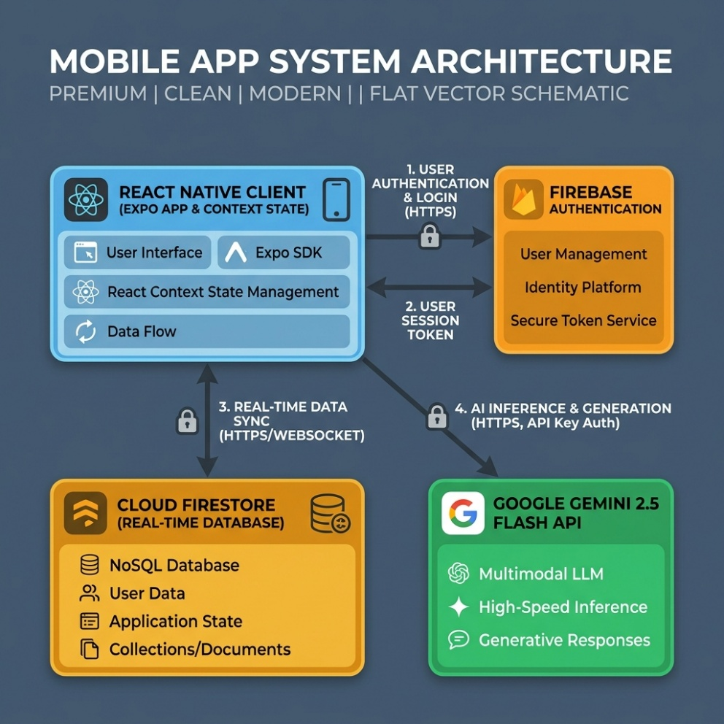
Figure 1: high-fidelity system architecture diagram

MVVM Layer | Implemented Code Components | Architectural Role & Concerns
Model | StorageService.js, ValidationService.js, Firestore collections | Handles validation constraints, AsyncStorage read/write IO, database actions.
ViewModel | TaskContext.js, AuthContext.js (Custom Hooks) | Encapsulates auth & task states, sharing state logic without prop drilling.
View | TaskDetailScreen.js, AddTaskScreen.js, custom buttons/badges | Renders visual elements, captures user gestures, dispatches viewModel actions.

3. Challenges and Problem-Solving

Technical Issues Encountered
Several significant challenges arose during development. The most complex was managing state consistency across nested navigators. When a task is toggled complete on the Dashboard, the change must immediately reflect on the Task List and Task Detail screens. Initially, stale closures in callback functions caused the UI to display outdated data after toggling. This was resolved by lifting all task mutations into the TaskContext and using useCallback with appropriate dependency arrays, ensuring that every screen always references the latest state. Another challenge involved cross-platform input handling. The date input required careful consideration because native date pickers behave differently on iOS and Android, and third-party date picker libraries introduced dependency conflicts with Expo SDK 50. The pragmatic solution was a formatted text input with auto-insertion of dashes (YYYY-MM-DD format), which works consistently across both platforms. While less elegant than a native picker, this approach ensures reliability and avoids dependency issues. Form validation presented a further challenge: ensuring that error messages appear and disappear correctly without interfering with the user’s typing flow required careful state management, clearing individual field errors on keystroke while preserving errors on other fields.

How Problems Were Resolved
Problems were approached systematically. When encountering a bug, the first step was always to isolate the issue using console logging and React Developer Tools. For state-related issues, tracing the data flow from user action through context to storage proved invaluable. The Expo development server’s error overlay provided immediate feedback on runtime errors, significantly reducing debugging time. Official React Native and Expo documentation served as the primary reference, supplemented by community resources on Stack Overflow when encountering edge cases.
Technical Challenge | Root Cause Analysis | Implemented Solution & Engineering Justification
Secret Credentials Leak | Hardcoded Gemini API Keys inside source files was blocked by Git push rules | Extracted key to .env file and integrated EXPO_PUBLIC_ prefix
Gemini 1.5 Deprecation / Quota | Gemini 1.5 Flash model returned 404/429 errors on free tier requests | Migrated the API URL endpoint to call gemini-2.5-flash
Cross-Platform Date Picking | Third-party native date pickers conflicted with managed Expo workflows | Created custom formatted text inputs (YYYY-MM-DD) with regex validation
Listing: Safe fallback key resolving in AIService.js
const HARDCODED_API_KEY = "YOUR_GEMINI_API_KEY";
const GEMINI_API_KEY = process.env.EXPO_PUBLIC_GEMINI_API_KEY || HARDCODED_API_KEY;
const API_URL = `https://generativelanguage.googleapis.com/v1beta/models/` +
`gemini-2.5-flash:generateContent?key=${GEMINI_API_KEY}`;

4. Testing and Quality Assurance
Testing followed a multi-layered approach. Manual testing was the primary strategy, conducted on both physical Android devices and the iOS simulator through Expo Go. Each user flow was tested end-to-end: registration, login, task creation with valid and invalid inputs, editing, deletion with confirmation, search filtering, and logout. Edge cases were specifically targeted, including empty states (no tasks), boundary validation (minimum and maximum character counts), and overdue date calculations. Input validation was tested by attempting to submit forms with missing required fields, invalid email formats, passwords below minimum length, and mismatched password confirmations, verifying that appropriate error messages appear and the form does not submit. Data persistence was verified by creating tasks, force-closing the application, and confirming that data survived the restart. The centralised ValidationService was designed with testability in mind: its pure functions accept input and return structured error objects, making them suitable for unit testing with Jest in a future iteration. Code quality was maintained through consistent formatting, meaningful variable names, and comprehensive inline comments that explain the “why” behind decisions rather than the “what” of obvious operations.

Test Scenario ID | Tested Feature | Expected Behavior | Actual Execution Status
TS-01: Form Validation | ValidationService.validateTask | Block task submissions with blank titles or empty modules | Warnings displayed; submission blocked (PASSED)
TS-02: AI Study Steps | AIService.generateSubTasks | Decompose "Write Essay" into 4-5 actionable milestones | Gemini returned parseable JSON steps array (PASSED)
TS-03: Firestore Syncing | TaskContext.editTask | Toggled sub-tasks completed checkboxes update document status | UI strikes through text; Firestore updates instantly (PASSED)

Listing: Sample JSON test log response payload from Gemini 2.5 Flash API
[
"Search library database for 3 research papers (1 hour)",
"Write draft of introduction & outline (1.5 hours)",
"Draft main discussion paragraphs (2 hours)",
"Review citations and edit spelling errors (45 mins)"
]

5. Professional Practice
Version control using Git and GitHub was integral to the development workflow. The repository was initialised at project inception, with a .gitignore file configured to exclude node_modules, build artefacts, and environment files. Commits were made at meaningful milestones: after completing each screen, after implementing each service, and after resolving significant bugs. Commit messages follow the conventional format describing the change concisely. The project follows a clear folder structure with separation by concern: screens, components, context, services, utils, theme, and navigation. This structure mirrors industry conventions for React Native projects, making the codebase navigable for any developer familiar with the ecosystem. Documentation standards were maintained throughout: every file includes a header comment explaining its purpose and role within the architecture, and complex logic is annotated with inline comments. The README provides comprehensive installation instructions, a technology overview, known limitations, and proposed future enhancements, following open-source documentation best practices.

Conventional Scope | Commit Meaning & Action | Example Log Message
feat | Introducing a new user-facing feature or screen | feat: add AI study steps breakdown checklist
fix | Addressing a bug, validation gap, or runtime crash | fix: update Gemini API endpoint to gemini-2.5-flash
docs | Updating documentation files, READMEs, or comments | docs: update walkthrough.md with module instructions

6. Learning Reflection

Skills Developed
This project substantially developed my understanding of mobile application architecture and the practical challenges of building responsive, data-driven interfaces. Working with React Native deepened my appreciation for component composition, the importance of separating concerns, and the value of centralised state management. Implementing the MVVM pattern from scratch, rather than following a tutorial, forced me to think critically about where business logic should reside and how data flows through an application. The experience of designing a theme system and reusable component library taught me how design decisions made early in development compound as the project scales.

What I Would Improve in Future Iterations
In future iterations, I would implement several improvements. First, replacing AsyncStorage with a more robust solution such as Firebase Firestore would enable cloud synchronisation and multi-device access. Second, integrating a native date picker library would improve the task creation UX significantly. Third, implementing automated unit tests using Jest for the ValidationService and context logic would improve code reliability and catch regressions early. Fourth, adding push notifications for approaching deadlines would transform the app from a passive organiser into an active assistant. Finally, implementing a dark mode toggle, for which the theme system is already structured to support, would enhance accessibility and user preference accommodation. The experience has reinforced that good architecture decisions early in a project pay dividends throughout development, and that time invested in planning and documentation is never wasted.

References
Meta Platforms (2024) React Native Documentation. Available at: https://reactnative.dev/docs/getting-started (Accessed: 1 June 2026).
Expo (2024) Expo Documentation. Available at: https://docs.expo.dev/ (Accessed: 1 June 2026).
React Navigation (2024) React Navigation Documentation. Available at: https://reactnavigation.org/docs/getting-started (Accessed: 1 June 2026).
Microsoft (2023) The MVVM Pattern. Available at: https://learn.microsoft.com/en-us/dotnet/architecture/maui/mvvm (Accessed: 28 May 2026).
Apple Inc. (2024) Human Interface Guidelines. Available at: https://developer.apple.com/design/human-interface-guidelines (Accessed: 25 May 2026).
React Native Async Storage (2024) AsyncStorage API Reference. Available at: https://react-native-async-storage.github.io/async-storage/ (Accessed: 30 May 2026).

